PSD2 Compliance for Log360
Automate PSD2 compliance and fortify cybersecurity resilience for financial institutions with Log360.
Region: EU | Type: Financial Services, Incident Management | Category: Compliance | Pricing: Free

Overview
The PSD2 compliance extension in Log360 helps organizations meet the Revised Payment Services Directive (PSD2, Directive (EU) 2015/2366), the EU directive governing electronic payment services and mandating Strong Customer Authentication for credit institutions and payment service providers by providing centralized log management, MFA event monitoring, and real-time security alerting. The platform supports PSD2 requirements for strong customer authentication, operational risk management, incident reporting, secure access control, fraud detection, audit trail integrity, and third-party provider oversight.
For Strong Customer Authentication (SCA), Log360 monitors MFA authentication events, Entra ID risky sign-ins, and AD logon activities to verify SCA compliance. To address Operational and Security Risk Management, the platform delivers system event monitoring, GPO auditing, network policy management, and policy change tracking to demonstrate risk governance. The extension also supports Major Incident Reporting and Detection by providing capabilities that correlates threat detection, antivirus, network attack, and FireEye reports to identify major incidents and generate evidence needed for regulatory notifications.

Key Features
- Secure Communication and Access Control: Log360 tracks user access events, Windows and Unix logon activity, cloud user authentication, and network device logons to enforce secure access policies.
- Fraud Detection and Prevention: Log360 tracks Entra ID risky sign-ins, failed logons across Windows and Unix, AWS unauthorized activity, and network attacks to detect fraudulent access attempts.
- Audit Trails and Accountability: Log360 centralizes EventLog, database audit, Oracle, SQL Server security, GPO auditing, and AD logon records.
- Third-Party Provider Access Management: Log360 monitors cloud storage integrations, AWS IAM activity, Salesforce access, and cloud user authentication logs to govern and audit all third-party access activity.


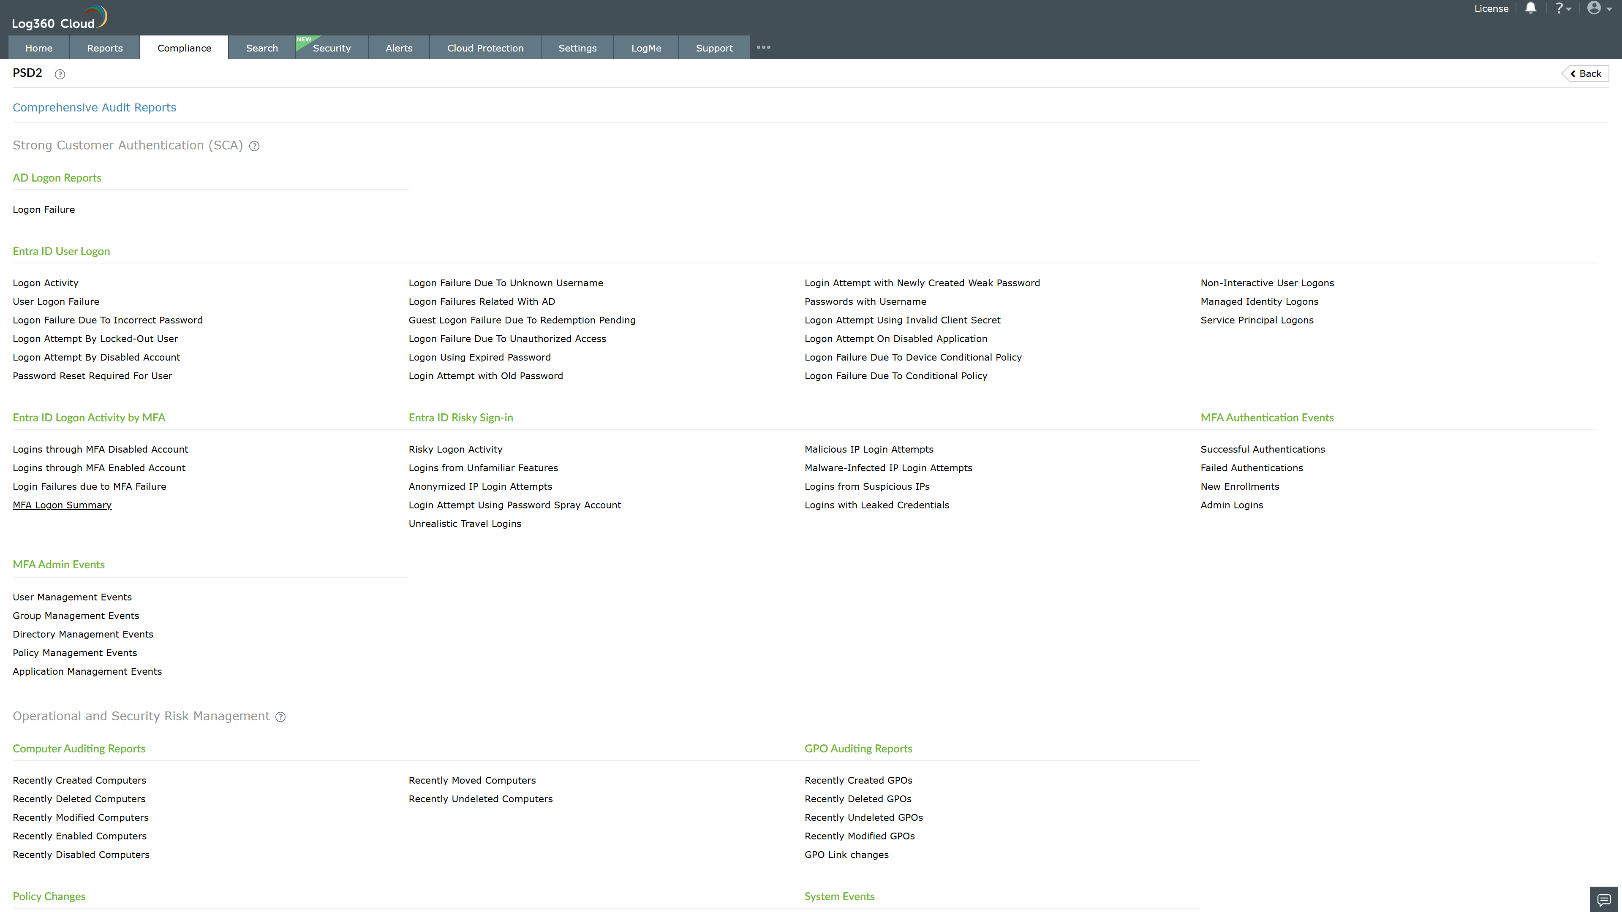
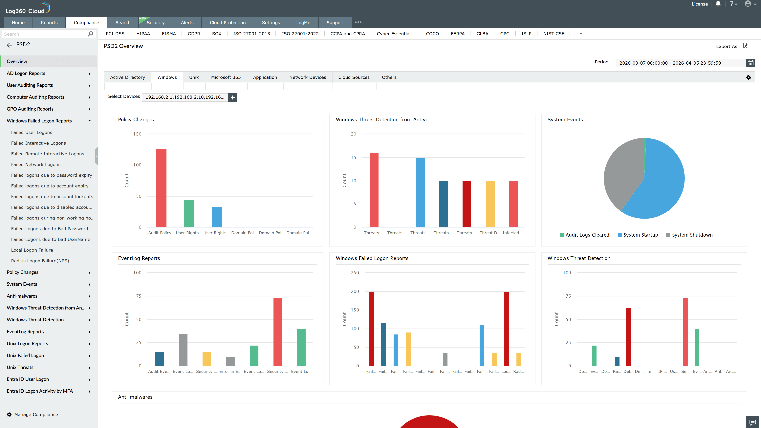
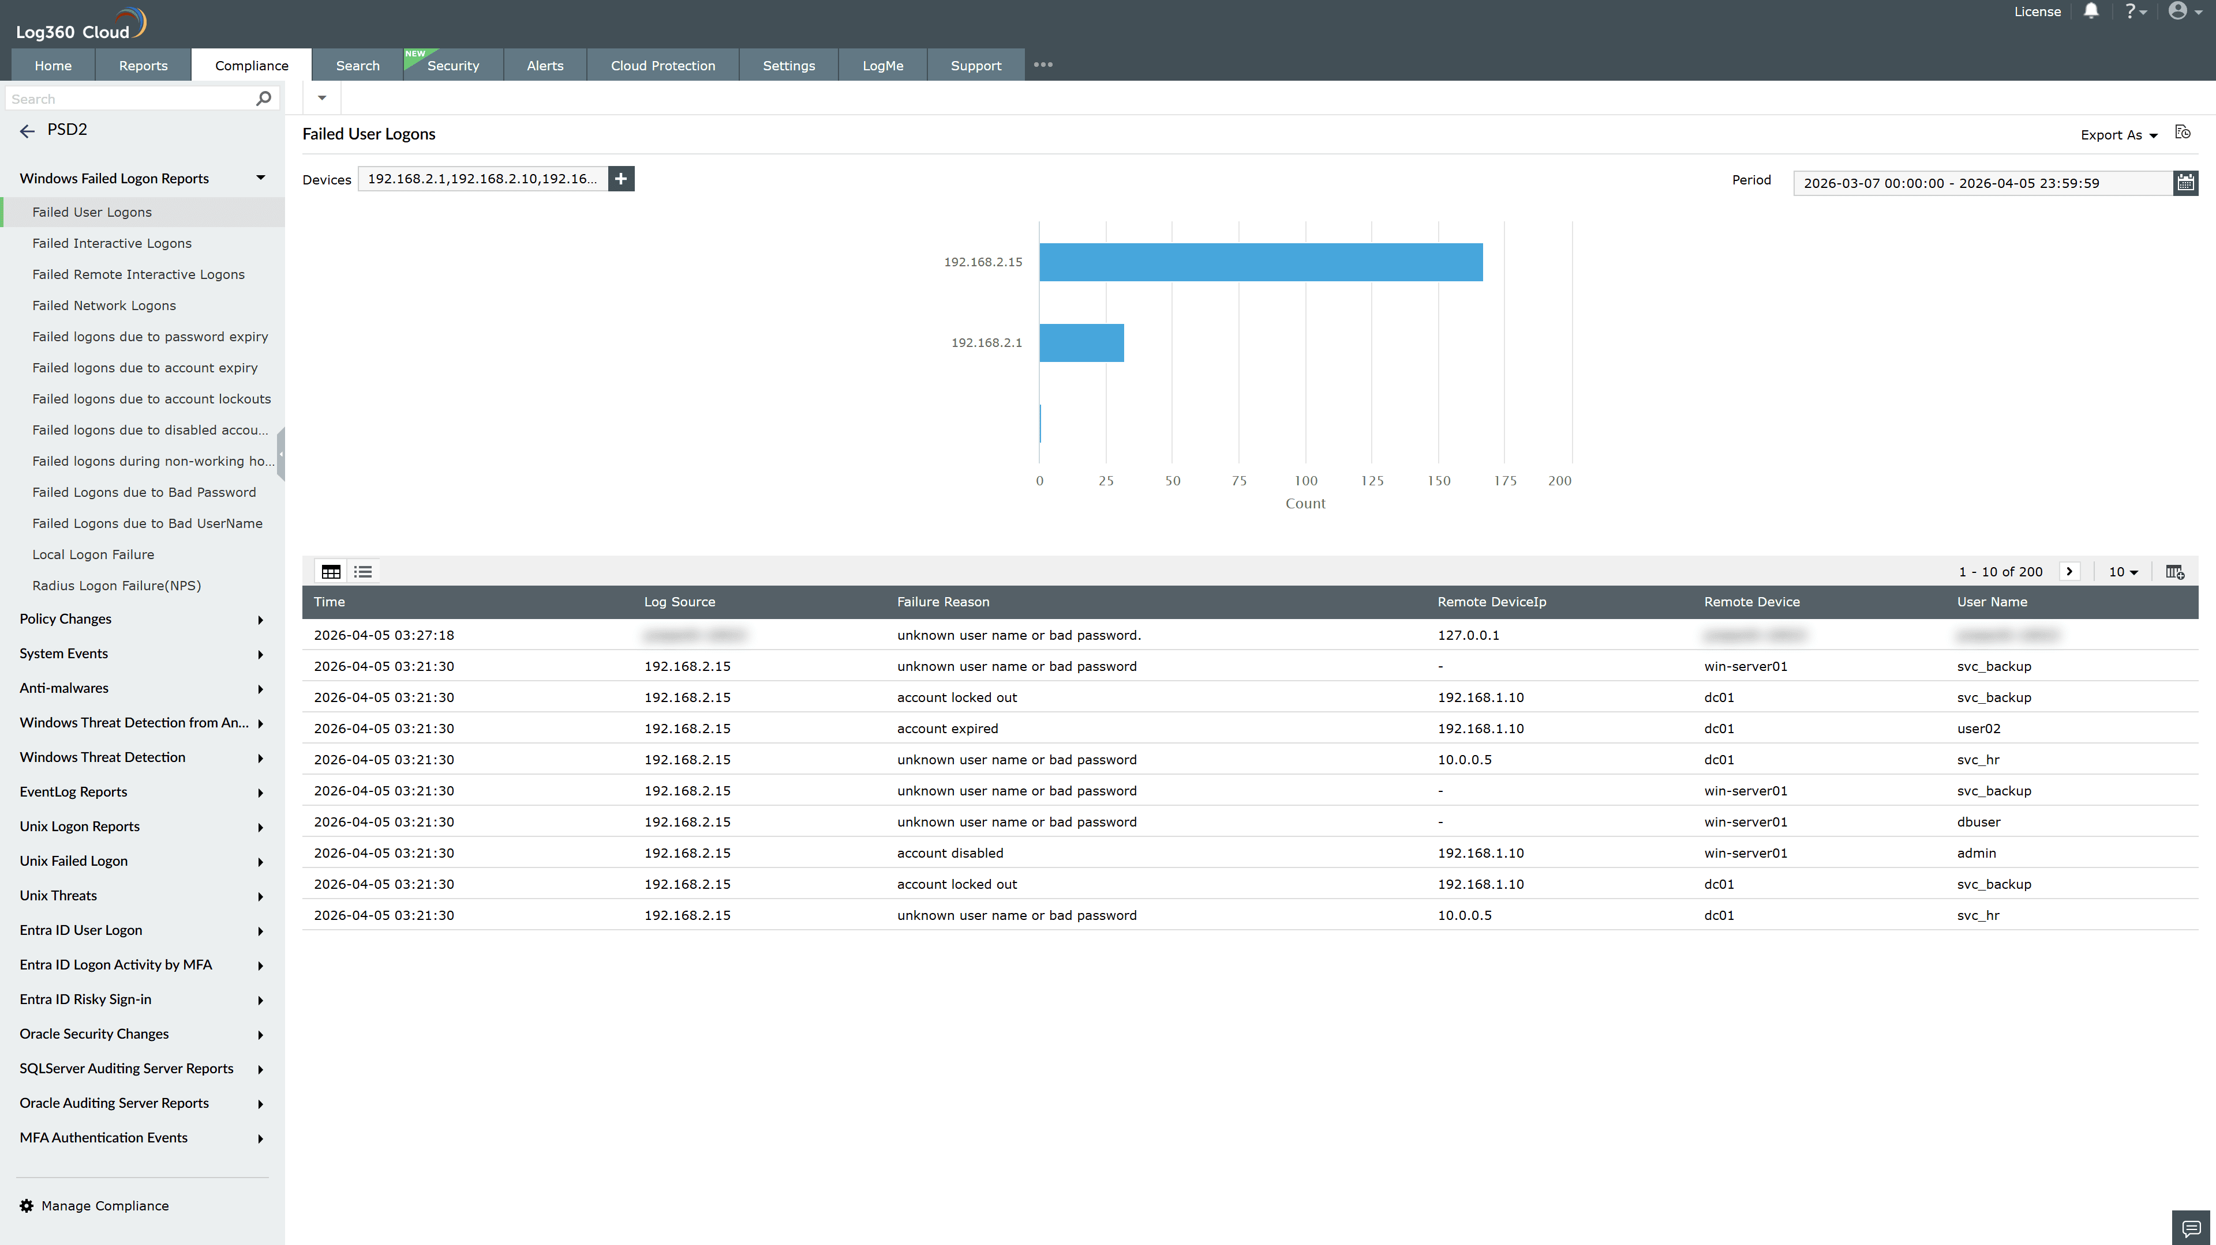
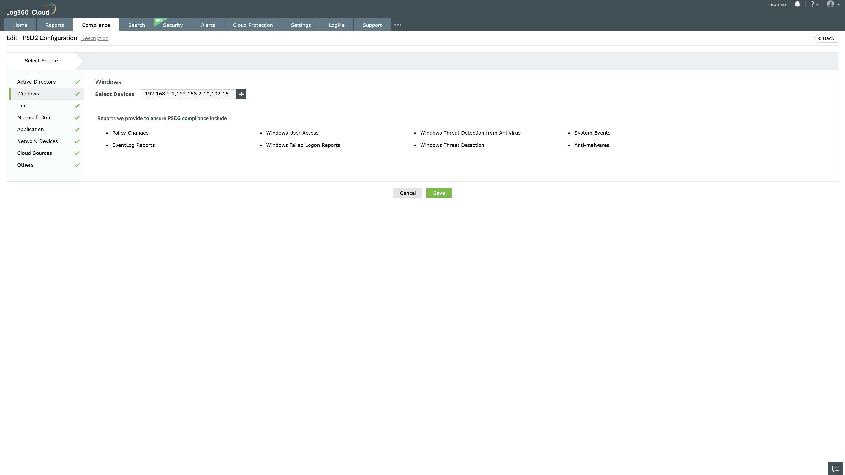
Valid Submission : Yes
Supported Editions : Free, Basic, Standard, Professional, MSSP
Help Document : https://www.manageengine.com/log-management/help/integrations/compliance-extensions.html
Help Video : Not provided
Tags : Log360, Compliance, Privacy monitoring, Data privacy, Regulatory compliance
Supported DCs : US, IN, JP, CA, AU, UK and EU
Privacy Policy:
Terms of Service:
Release Notes:
Predefined reports for the PSD2.

